Montessorischool Zwolle
Breuken & Procenten
Toets

Onderdeel: Breuken

Opgave 1
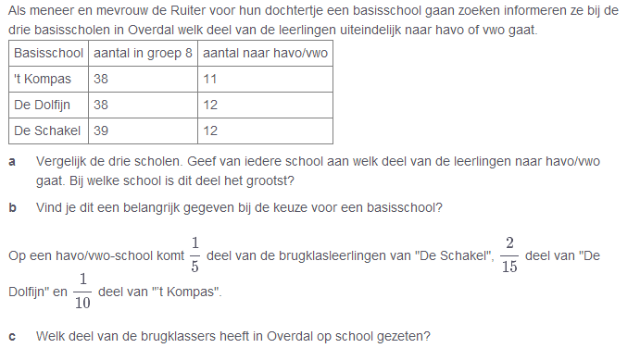
________________________________________________________________________________________________________________________________________________________________________________________________________________________________________________________________________________________________________________________________________________________________________________________________________________________________________________________________________________________________________________________________________________________________________________________________________________________________________________________________________________________________________________________________________________________________________________________________________________________________________________________________________________________________________________________________________________________________________________________________________________________________________________________________________________________________________________________________________________________________________________________________________________________________________________________________________________________________________________________________________________________________________________________________________________________________________________________________________________________________________________________________________________________________________________________________________________________________________________________________________________________________________________________________________________________________________________________________________________________________________________________________________________________________________________________________________________________________________________________________________________________________________________

Opgave 2
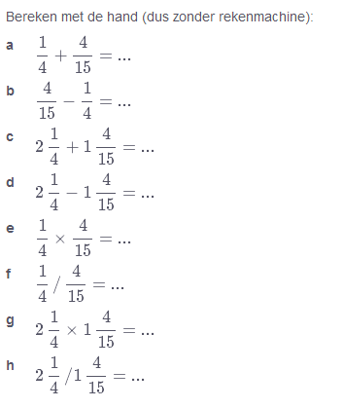
______________________________________________________________________________________________________________________________________________________________________________________________________________________________________________________________________________________________________________________________________________________________________________________________________________________________________________________________________________________________________________________________________________________________________________________________________________________________________________________________________________________________________________________________________________________________________________________________________________________________________________________________________________________________________________________________________________________________________________________________________________________________________________________________________________________________________________________________________________________________________________________________________________________________________________________________________________________________________________________________________________________________________________________________________________________________________________________________________________________________________________________________________________________________________________________________________________________________________________________________________________________________________________________________________________________________________________________________________________________________________________________________________________________________________________________________________________________________________________________________________________________________________________________________________________________________________________________________________________________________________________________________________________________________________________________________________________________________________

Opgave 3
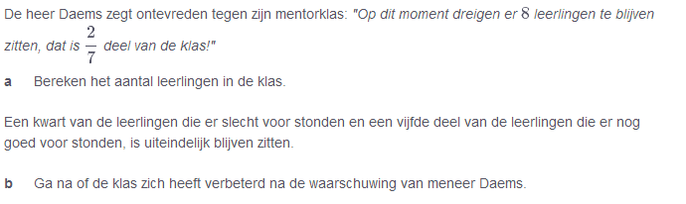
________________________________________________________________________________________________________________________________________________________________________________________________________________________________________________________________________________________________________________________________________________________________________________________________________________________________________________________________________________________________________________________________________________________________________________________________________________________________________________________________________________________________________________________________________________________________________________________________________________________________________________________________________________________________________________________________________________________________________________________________________________________________________________________________________________________________________________________________________________________________________________________________________________________________________________________________________________________________________________________________________________________________________________________________________________________________________________________________________________________________________________________________________________________________________________________________________________________________________________________________________________________________________________________________________________________________________________________________________________________________________________________________________________________________________________________________________________________________________________________________________________________________________________________________________________________________________________________________________________________________________________________________________________________________________________________________________________________________________________________________________________________________________________________________________________________________________________________________________________________________________________________________________________________________________________________________________________________________________________________________________________________________________________________________________________________________________________________________________________________________________________________________________________________________________________________________________________________________________________________________________________________________________________________________________

Opgave 4
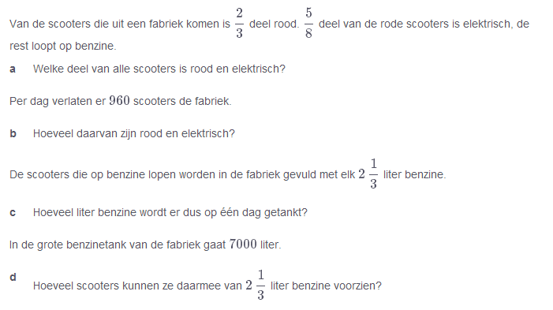
__________________________________________________________________________________________________________________________________________________________________________________________________________________________________________________________________________________________________________________________________________________________________________________________________________________________________________________________________________________________________________________________________________________________________________________________________________________________________________________________________________________________________________________________________________________________________________________________________________________________________________________________________________________________________________________________________________________________________________________________________________________________________________________________________________________________________________________________________________________________________________________________________________________________________________________________________________________________________________________________________________________________________________________________________________________________________________________________________________________________________________________________________________________________________________________________________________________________________________________________________________________________________________________________________________________________________________________________________________________________________________________________________________________________________________________________________________________________________________________________________________________________________________________________________________________________________________________________________________________________________________________________________________________________________________________________________________________________________________________________________________________________________________________________________________________________________________________________________________________________________________________________________________________________________________________________________________________________________________________________________________________________________________________________________________________________________________________________________________________

Onderdeel: Procenten

Opgave 1
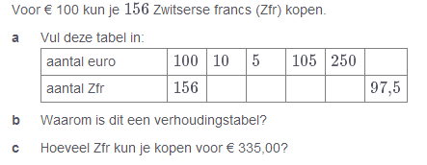
____________________________________________________________________________________________________________________________________________________________________________________________________________________________________________________________________________________________________________________________________________________________________________________________________________________________________________________________________________________________________________________________________________________________________________________________________________________________________________________________________________________________________________________________________________________________________________________________________________________________________________________________________________________________________________________________________________________________________________________________________________________________________________________________________________________________________________________________________________________________________________________________________________________________________________________________________________________________________________________________________________________________________________________________________________________________________________________________________________________________________________________________________________________________________________________________________________________________________________________________________________________________________________________________________________________________________________________________________________________________________________________________________________________________________________________________________________________________________________________________________________________________________________________________________________________________________________________________________________________________________________________________________________________________________________________________________________________________________________________________________________________________________________________________________________________________________________________________________________________________________________________________________________________________

Opgave 2
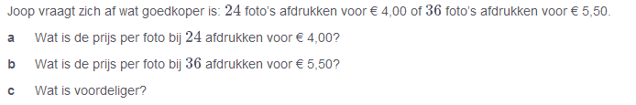
____________________________________________________________________________________________________________________________________________________________________________________________________________________________________________________________________________________________________________________________________________________________________________________________________________________________________________________________________________________________________________________________________________________________________________________________________________________________________________________________________________________________________________________________________________________________________________________________________________________________________________________________________________________________________________________________________________________________________________________________________________________________________________________________________________________________________________________________________________________________________________________________________________________________________________________________________________________________________________________________________________________________________________________________________________________________________________________________________________________________________________________________________________________________________________________________________________________________________________________________________________________________________________________________________________________________________________________________________________________________________________________________________________________________________________________________________________________________________________________________________________________________________________________________________________________________________________________________________________________________________________________________________________________________________________________________________________________________________________________________________________________________________________________________________________________________________________________________________________________________________________________________________________________________________________________________________________________________________________________________________________________________________________________________________________________________________________________________________________________________________________________________________________________________________________________________________________________________________________________________________________________________________________________________________________________________________________________________________________________________________________________________________________________________________________

Opgave 3
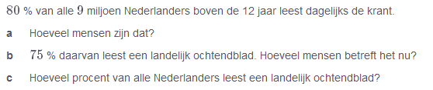
____________________________________________________________________________________________________________________________________________________________________________________________________________________________________________________________________________________________________________________________________________________________________________________________________________________________________________________________________________________________________________________________________________________________________________________________________________________________________________________________________________________________________________________________________________________________________________________________________________________________________________________________________________________________________________________________________________________________________________________________________________________________________________________________________________________________________________________________________________________________________________________________________________________________________________________________________________________________________________________________________________________________________________________________________________________________________________________________________________________________________________________________________________________________________________________________________________________________________________________________________________________________________________________________________________________________________________________________________________________________________________________________________________________________________________________________________________________________________________________________________________________________________________________________________________________________________________________________________________________________________________________________________________________________________________________________________________________________________________________________________________________________________________________________________________________________________________________________________________________________________________________________________________________________________________________________________________________________________________________________________________________________________________________________________________________________________________________________________________________________________________________________________________________________________________________________________________________________________________________________________________________________________________________________________________________________________________________________________________________________________________________________________________________________________________

Opgave 4



